**Design Patterns and Principles**

Exercise 1: Implementing the Singleton Pattern

Code

) Logger.java

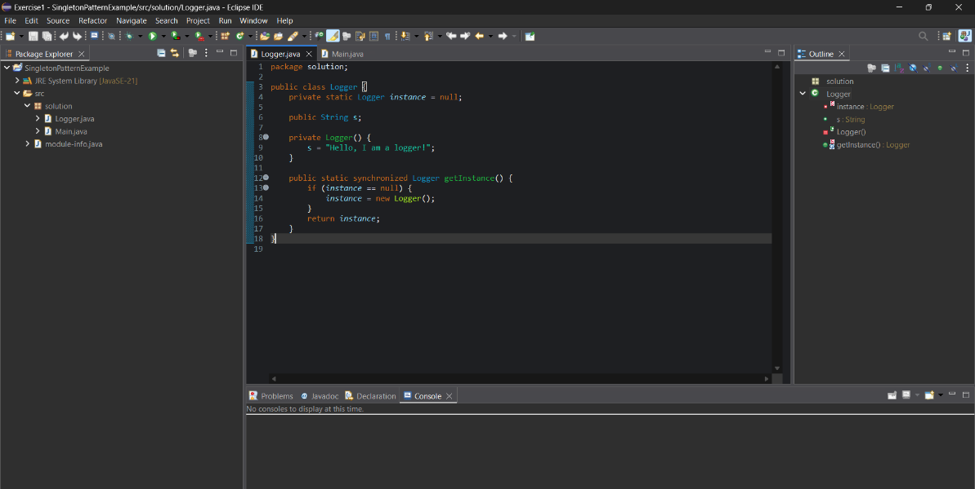

) Main.java

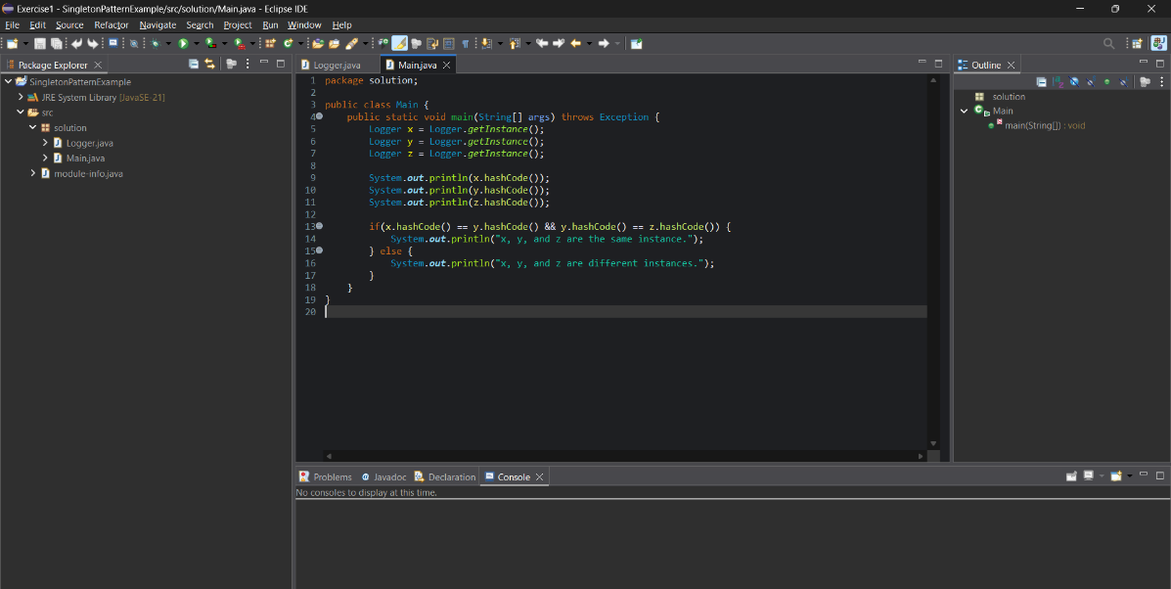

**Output**

) Terminal

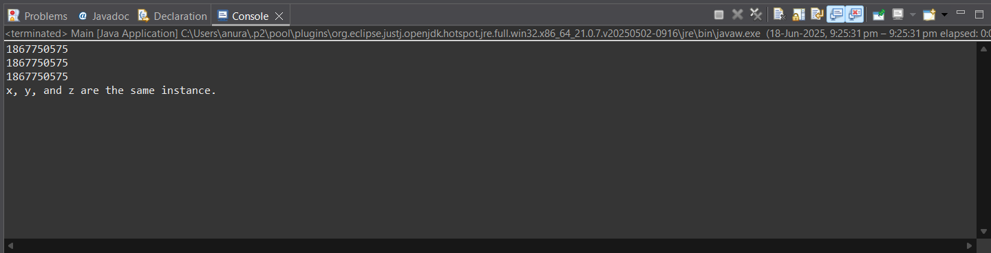

Exercise 2: Implementing the Factory Method Pattern

Code

) Document.java

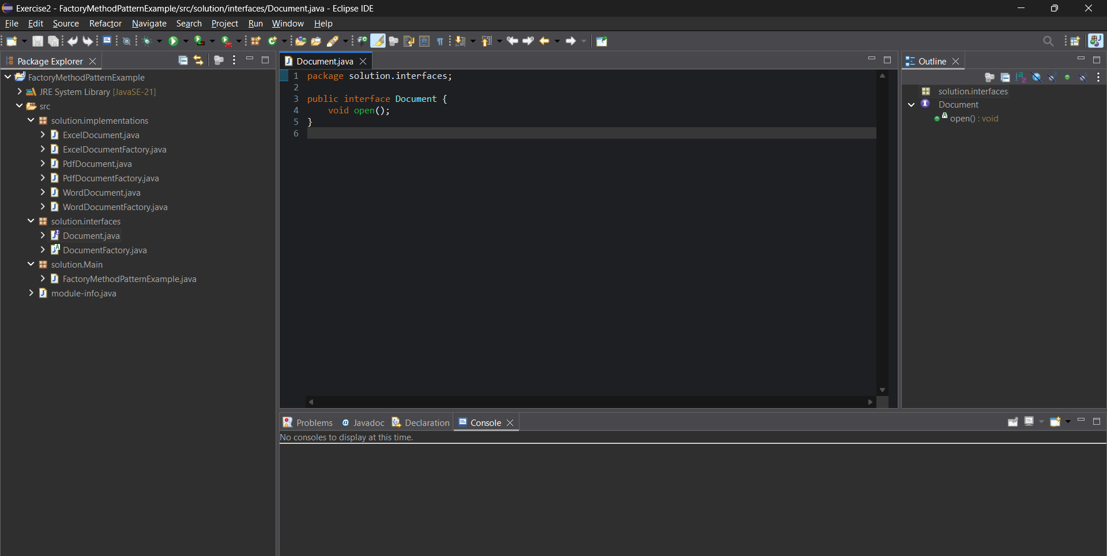

) WordDocument.java

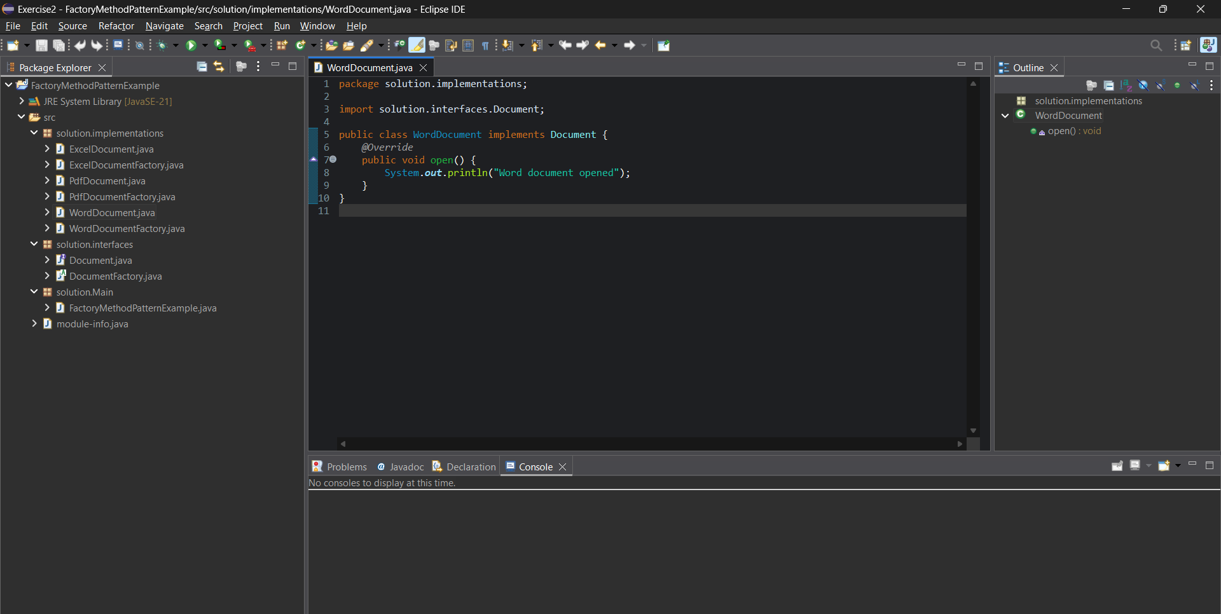

) PdfDocument.java

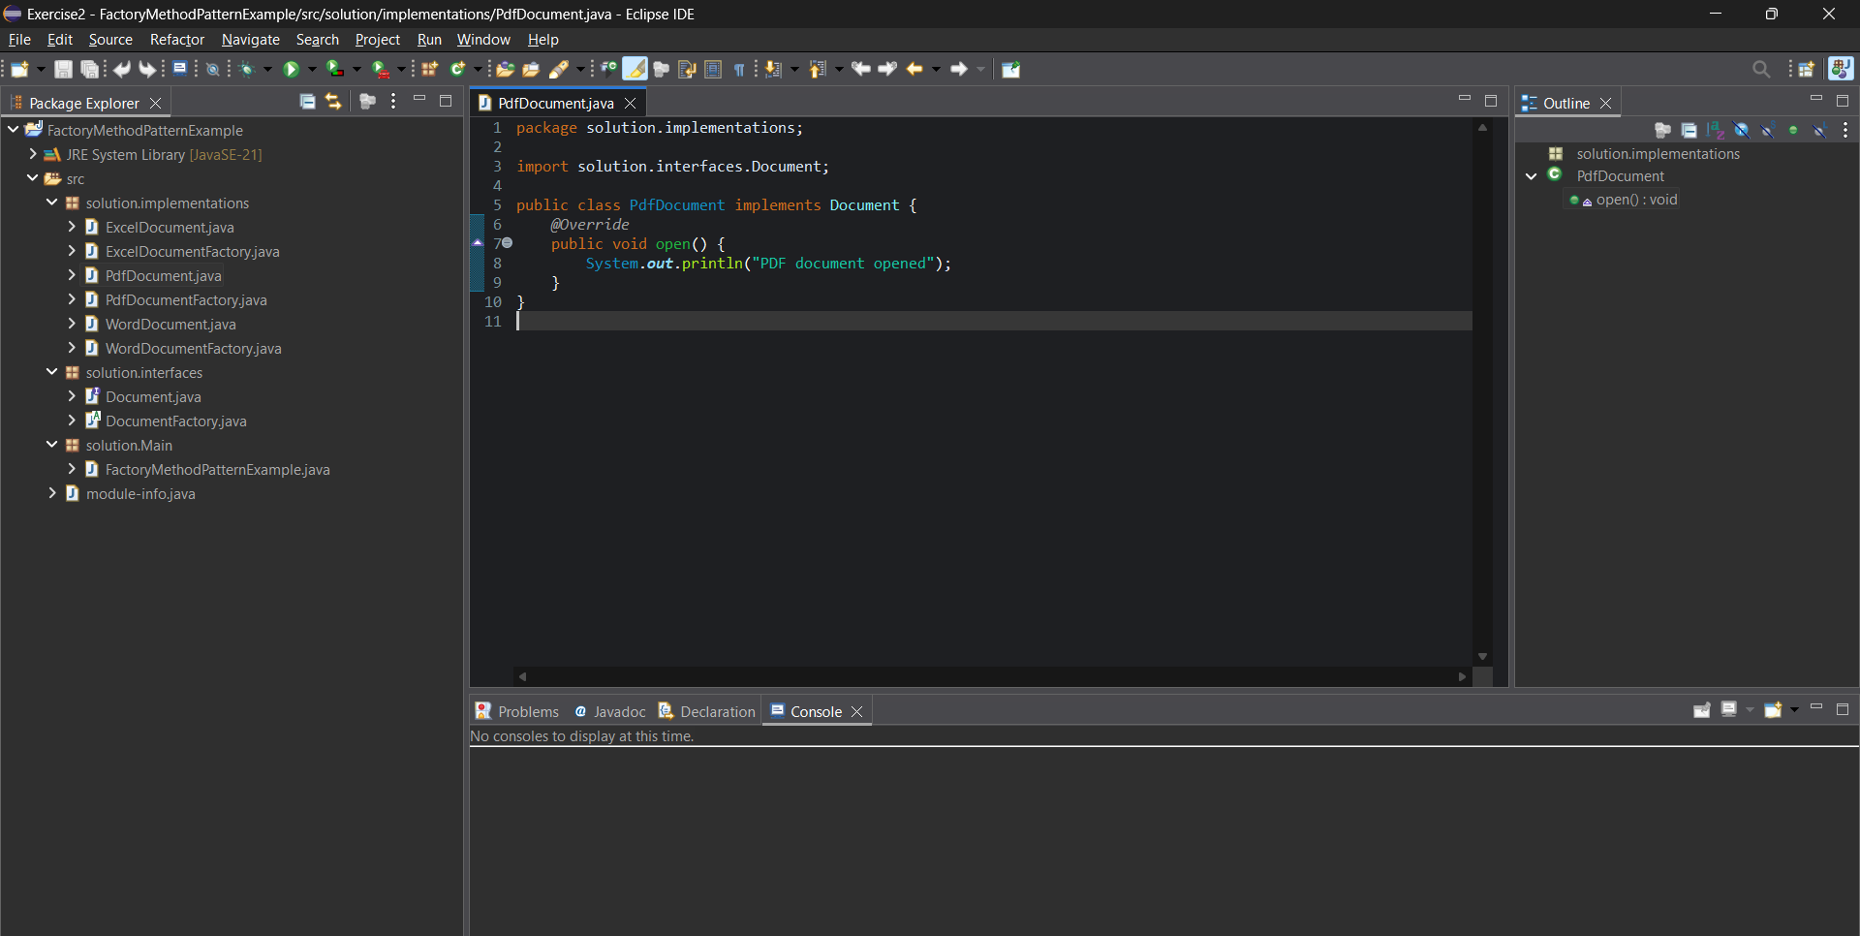

) ExcelDocument.java

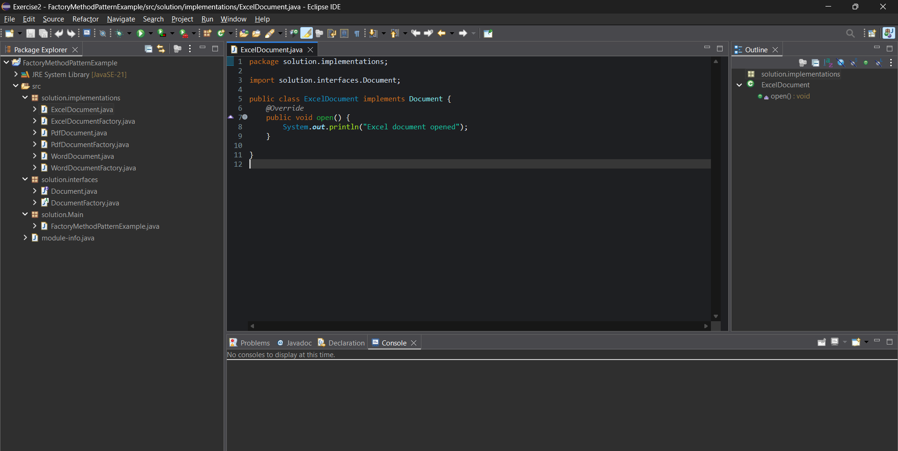

) DocumentFactory.java

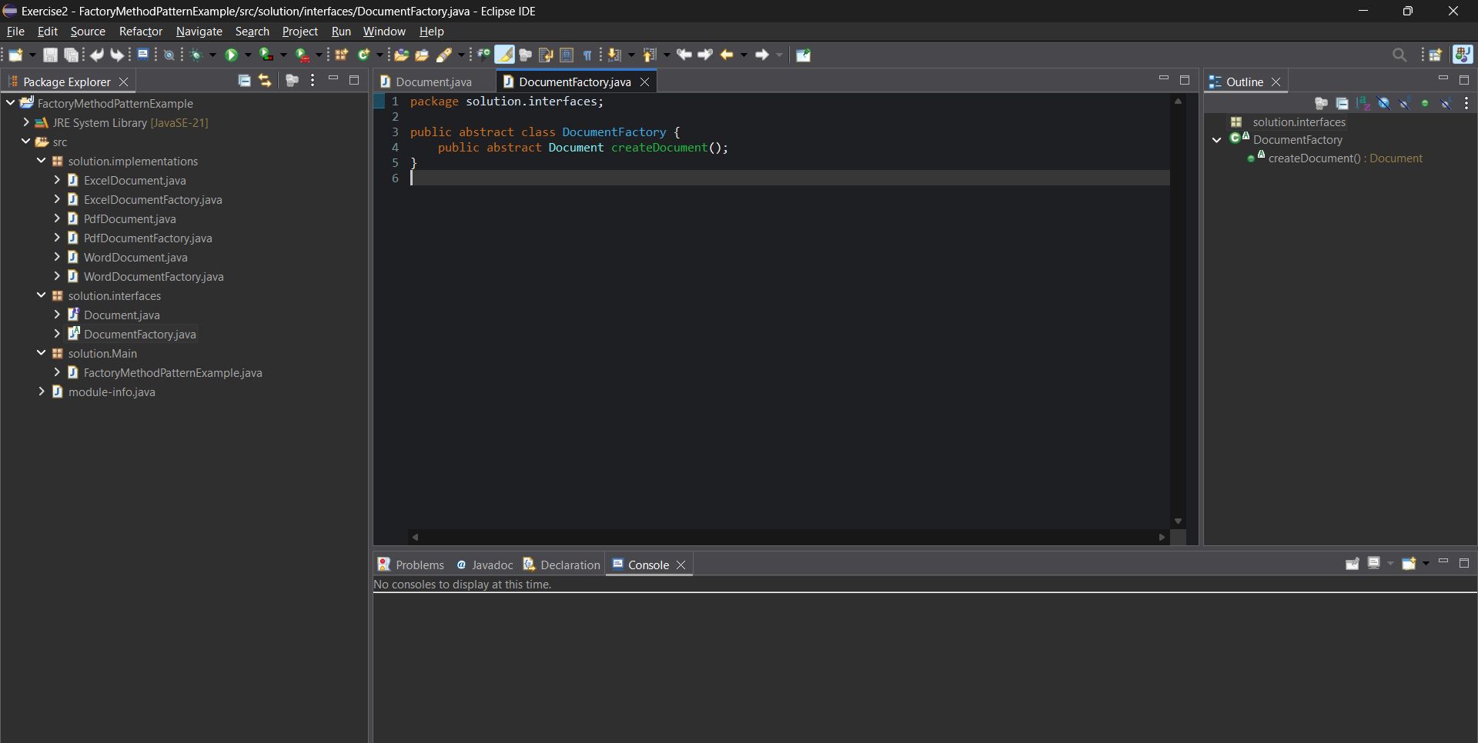

) WordDocumentFactory.java

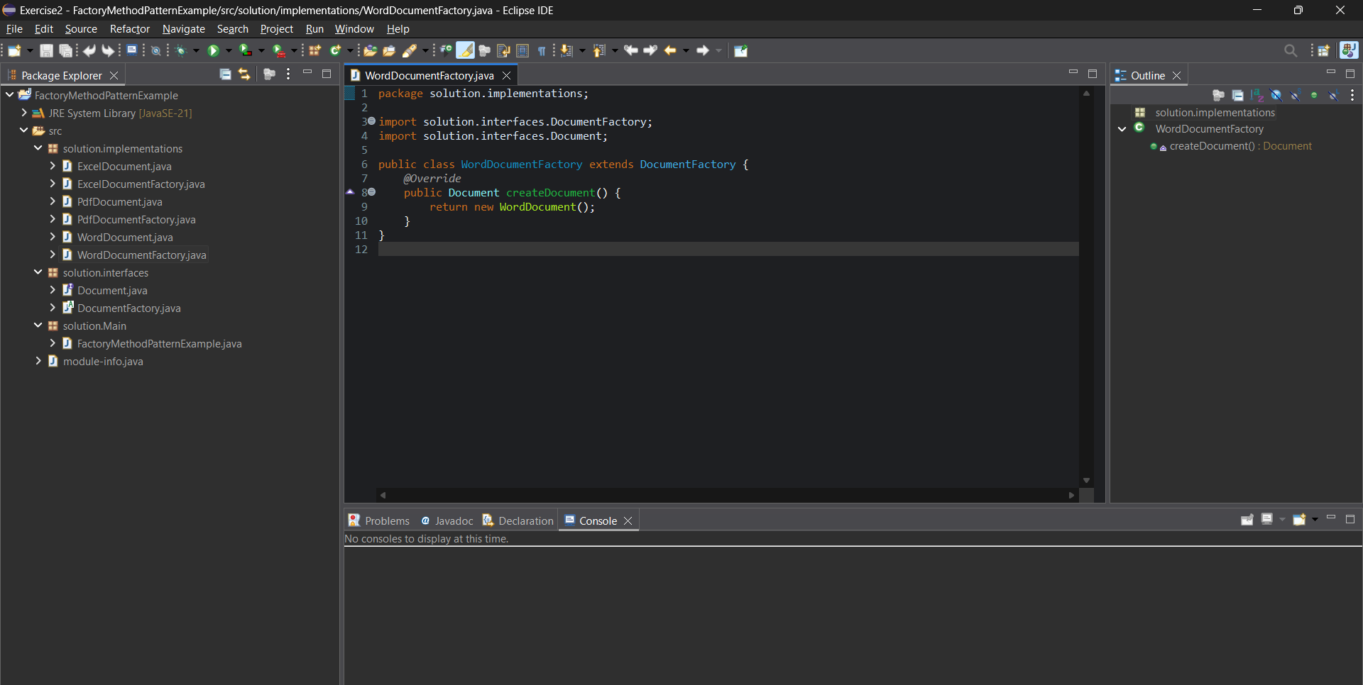

) PdfDocumentFactory.java

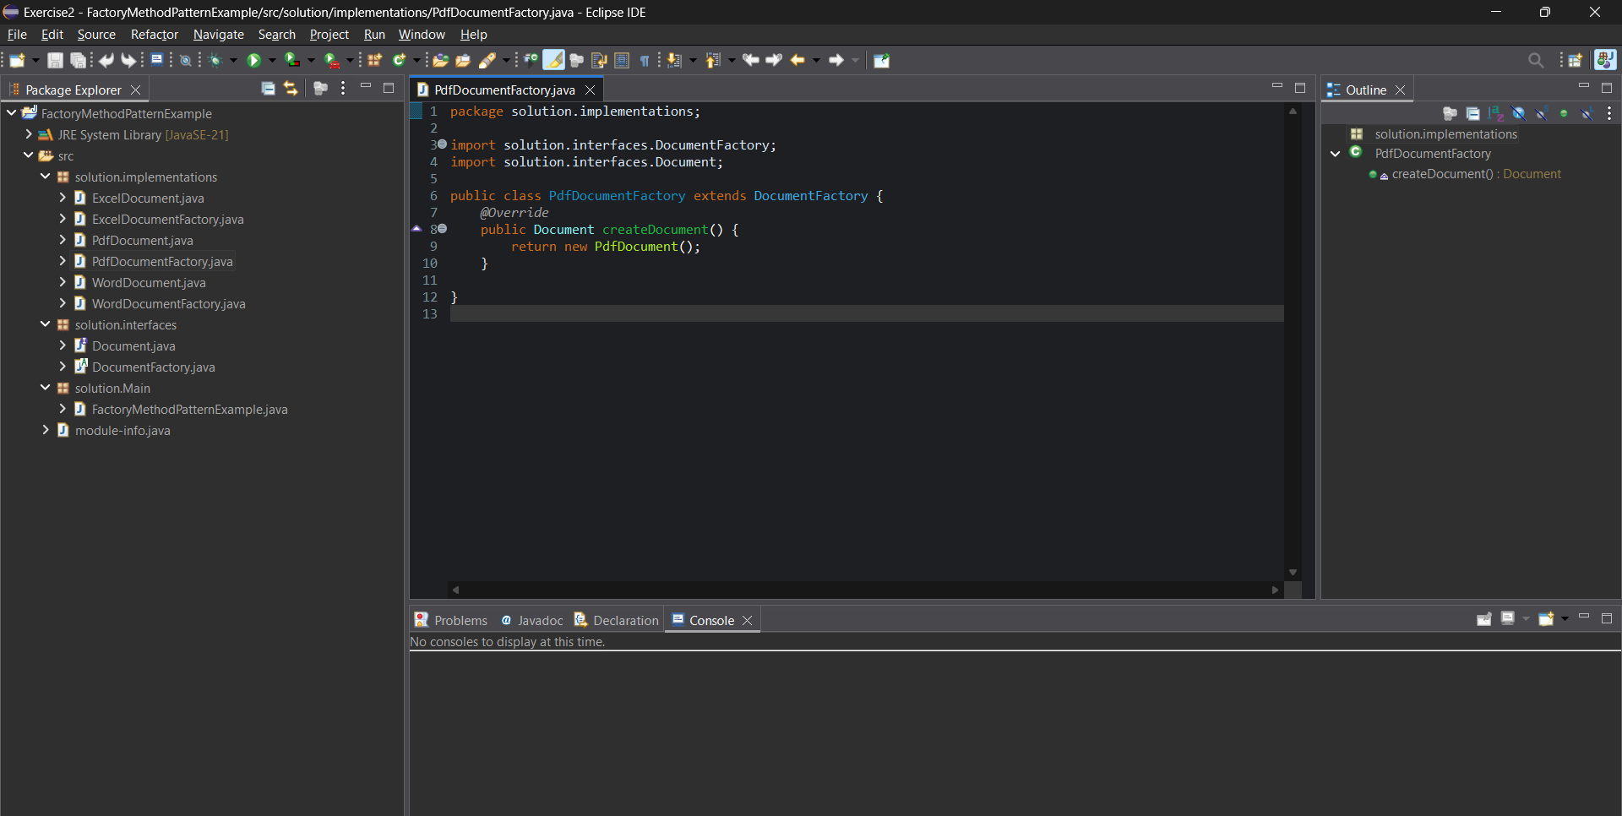

) ExcelDocumentFactory.java

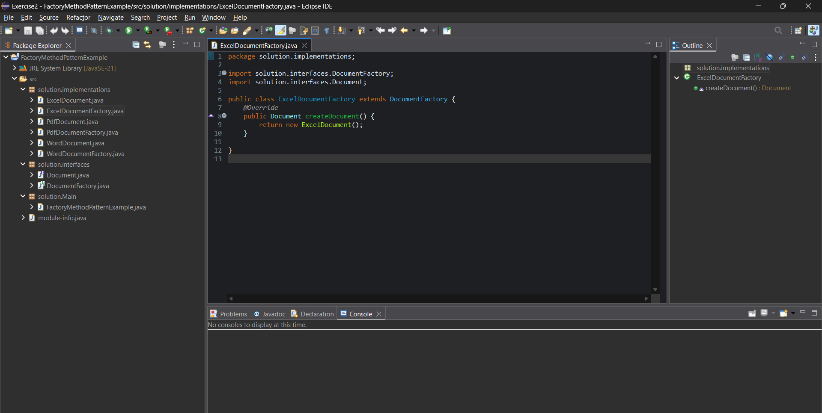

) FactoryMethodPatternExample.java

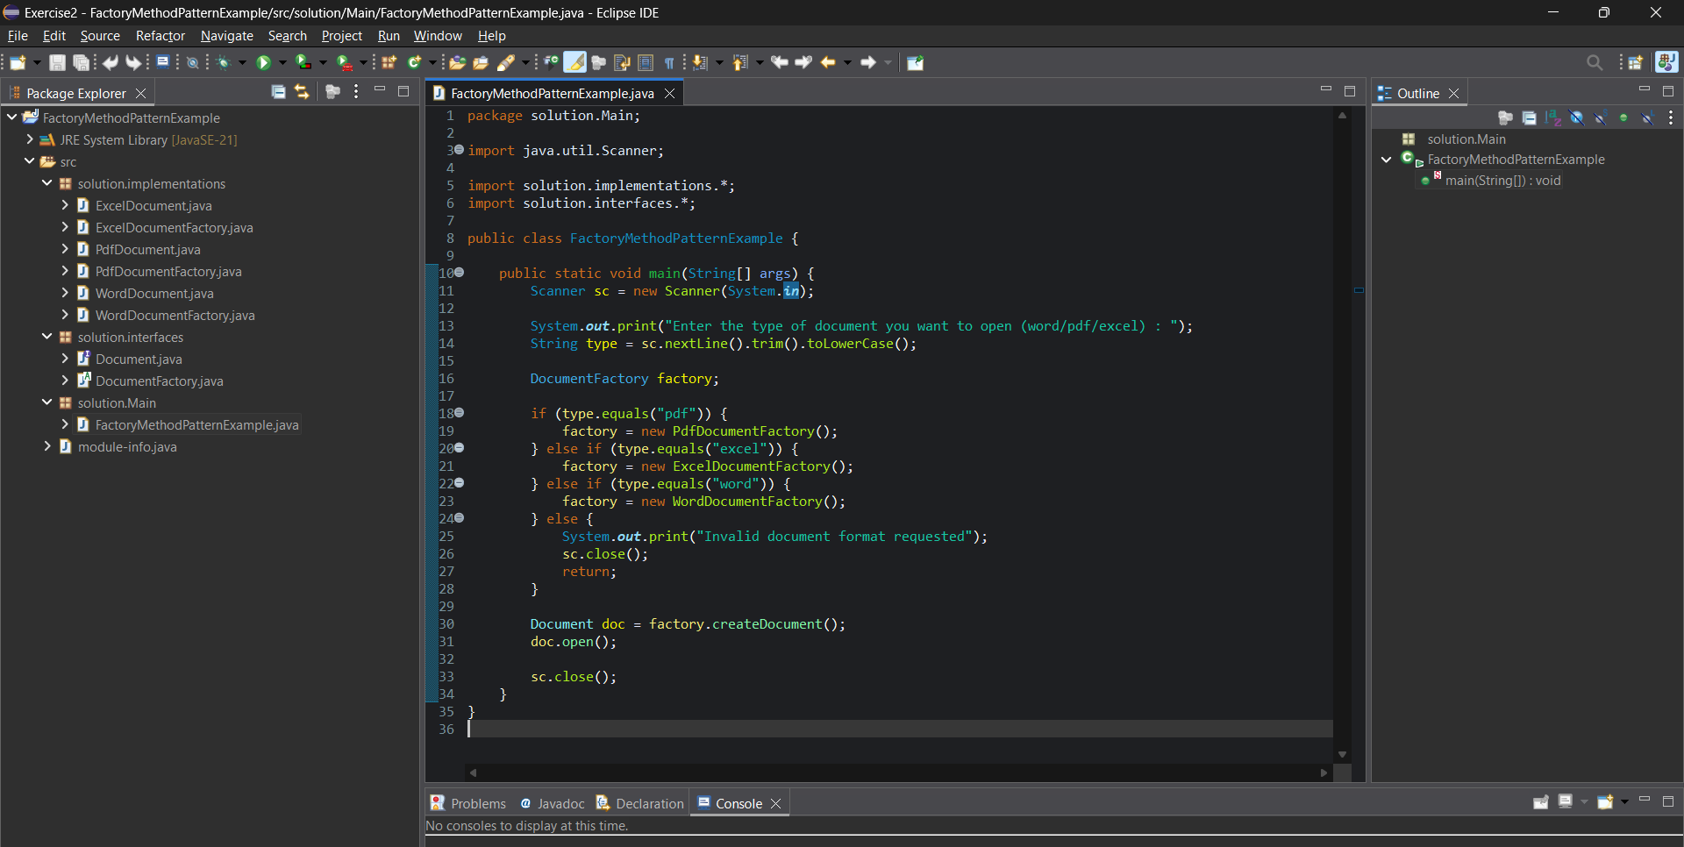

Output

) input = pdf

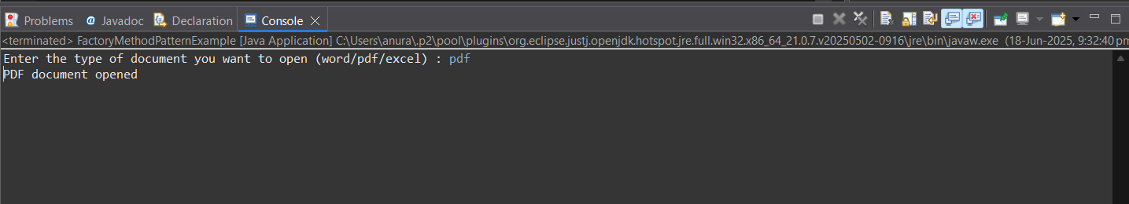

) input = excel

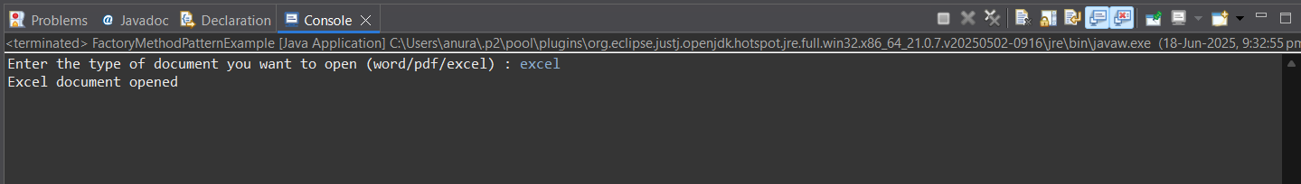

) input = word

